Project Summary of “Health Care” Application
Executive Summary:
This project aims to assist individuals aged 65 and above in leading healthy and better lives. By utilizing Angular the project enables users to manage their diet plans, medicine schedules, and access vital
healthcare information. The application provides personalized diet plans, tracks medicine schedules, and offers
information on nearby hospitals, medical stores, and emergency contacts.
Introduction:
The project addresses the need for elderly individuals to manage their health and well-being effectively. It aims to provide
a user-friendly solution for organizing diet plans, medicine schedules, and accessing important healthcare resources. The
objectives include improving the quality of life and promoting independence among elderly individuals.
Frontend Development:
The frontend development utilizes Angular to create an interactive and user-friendly interface. It enables elderly
individuals to navigate and interact with the application effortlessly.
frontend ensuring smooth data transmission and retrieval.
Conclusion:
This project successfully addresses the needs of individuals aged 65 and above by providing a comprehensive solution for
managing their health. The application facilitates the management of diet plans, medicine schedules, and access to
essential healthcare information. Future enhancements may include a mobile application, reminder notifications, machine
learning for personalization, integration with wearable devices, community support features, telemedicine services, and
advanced analytics. Challenges faced during development include understanding user needs, integrating technologies,
usability and accessibility, data validation and security, scalability and performance, and adopting an iterative development approach. These challenges have led to valuable learnings and growth for the development team, resulting
in a robust and functional application.

Screenshot’s:
Home page:
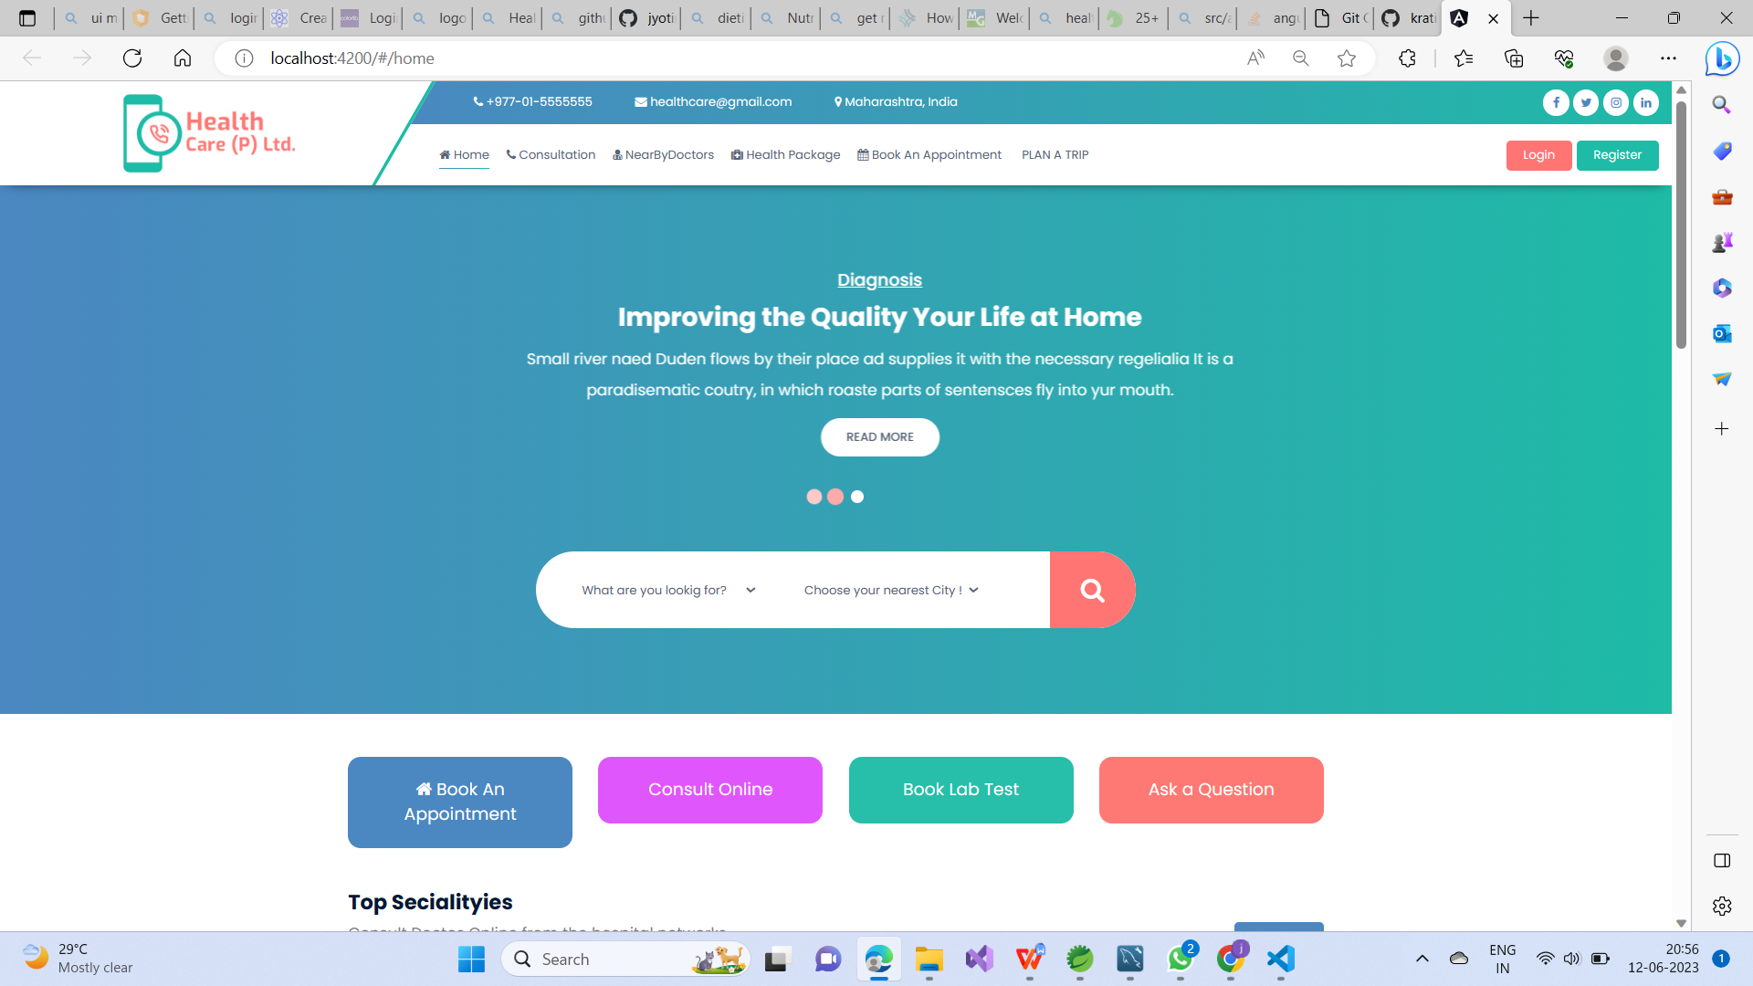
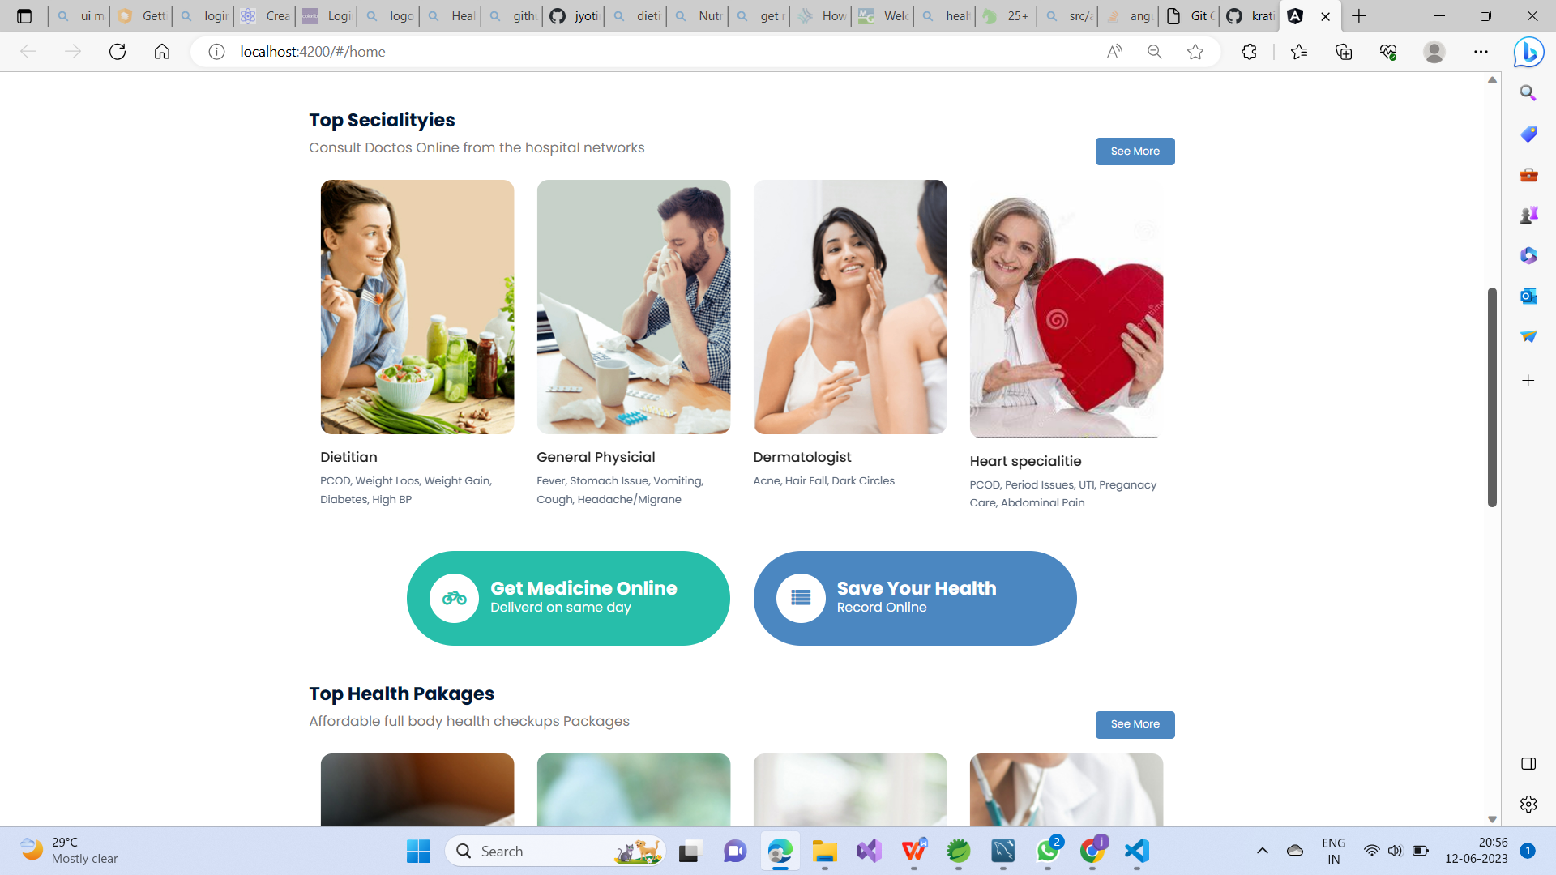
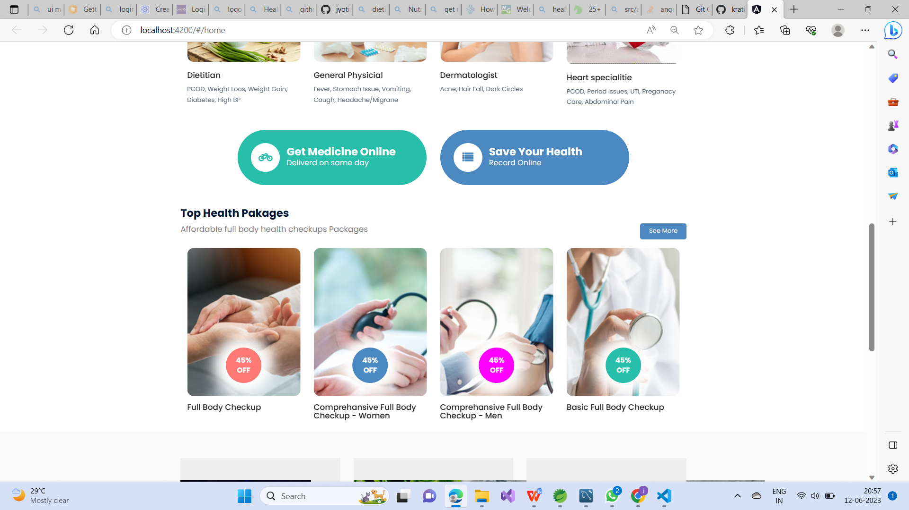

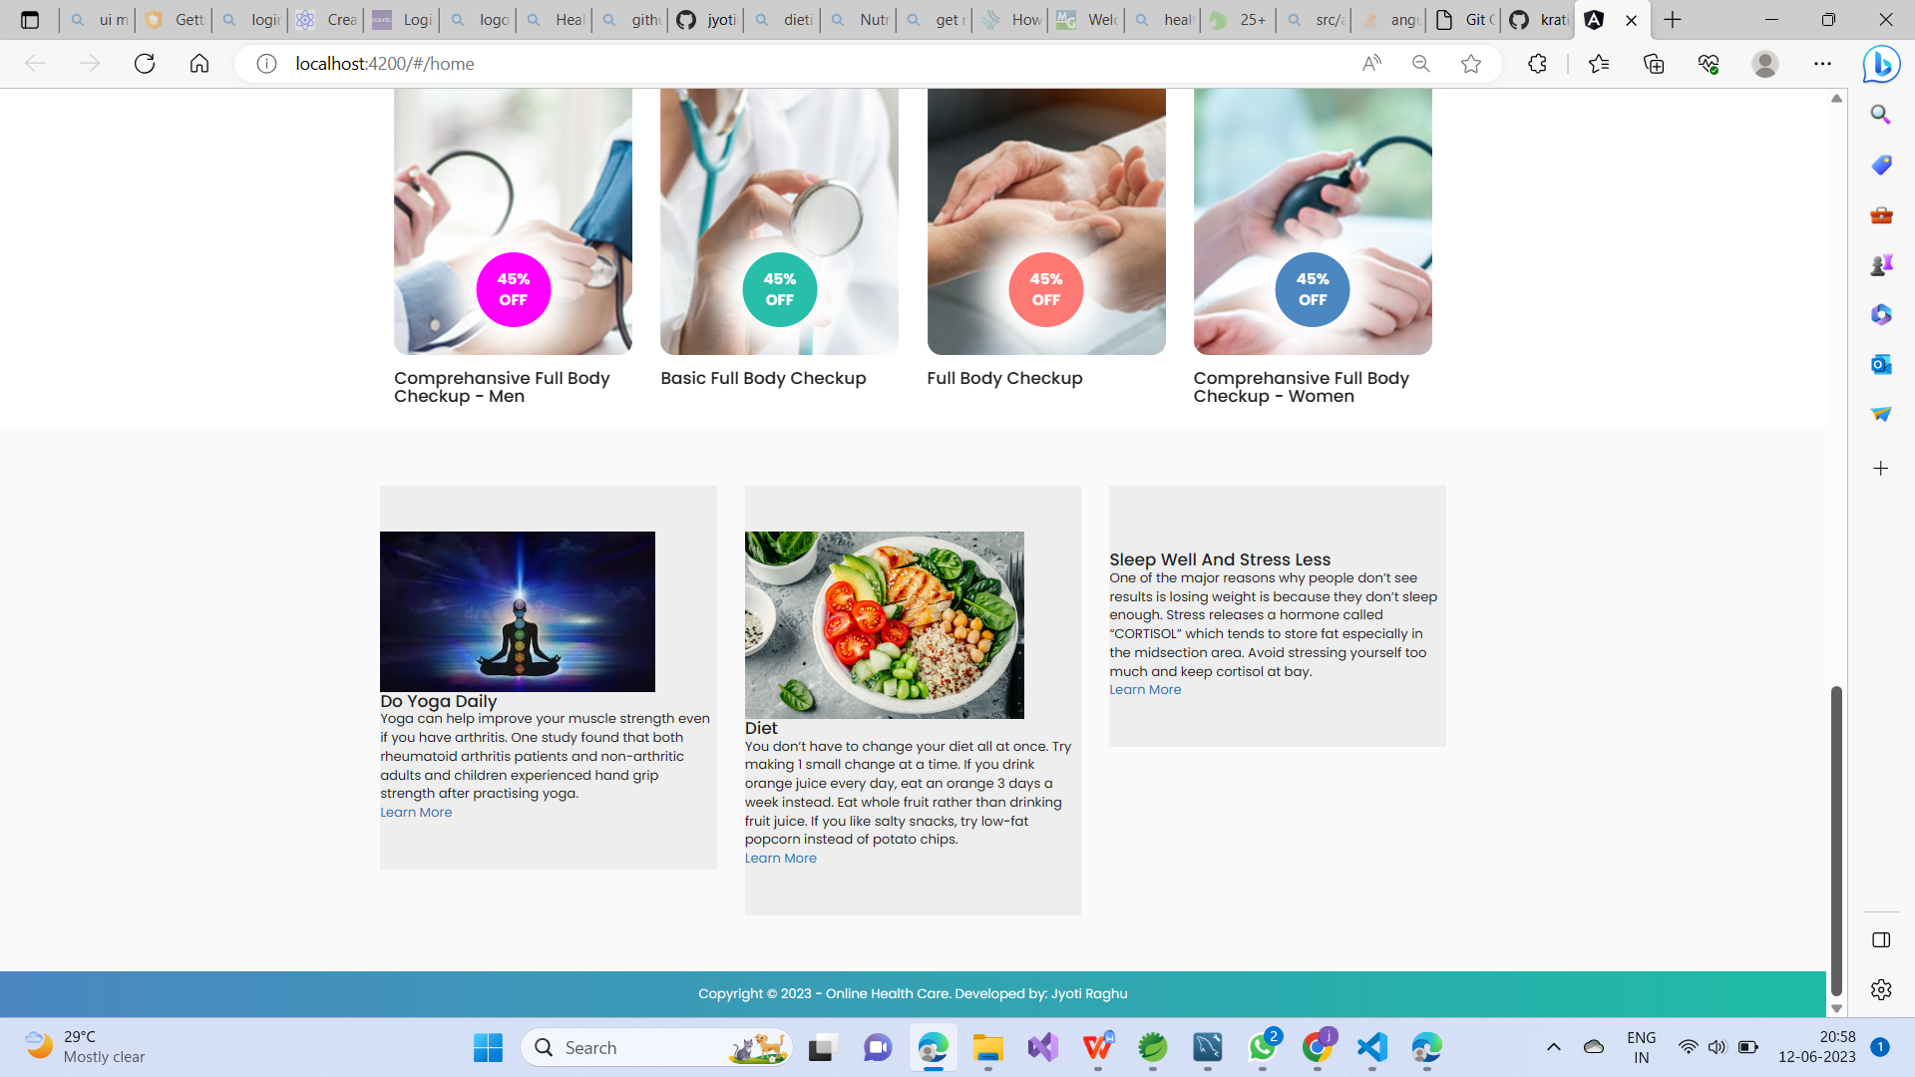

Login:
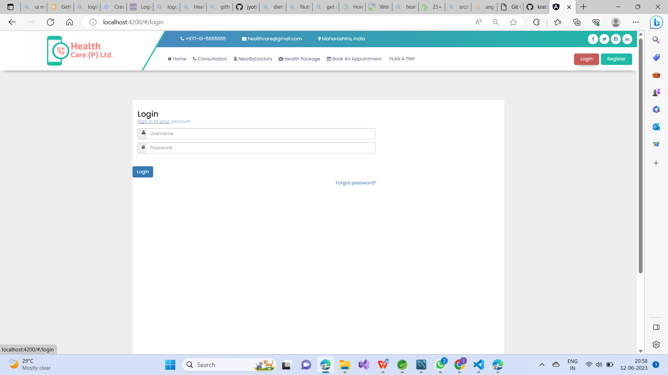

Register:

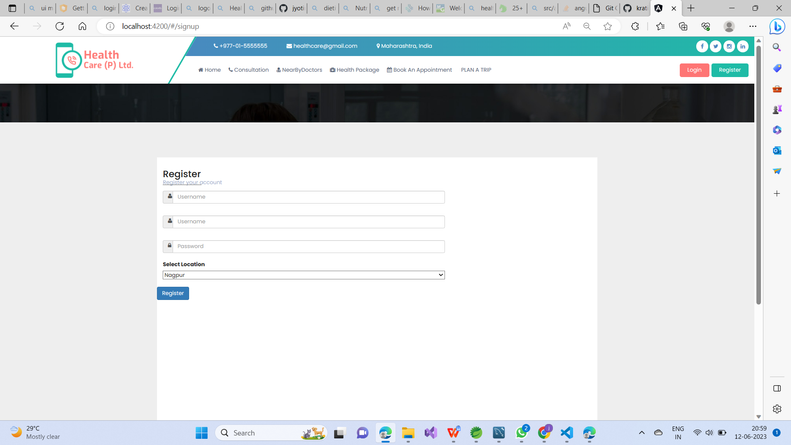
Book An Appointment:

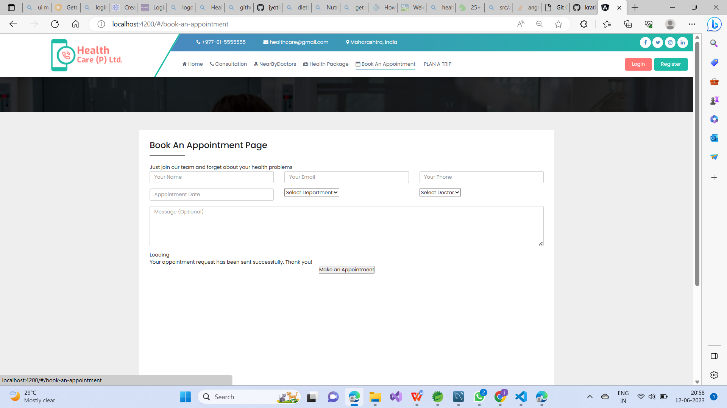

Nearby Doctors:


